Testing Evidence

Case 1:
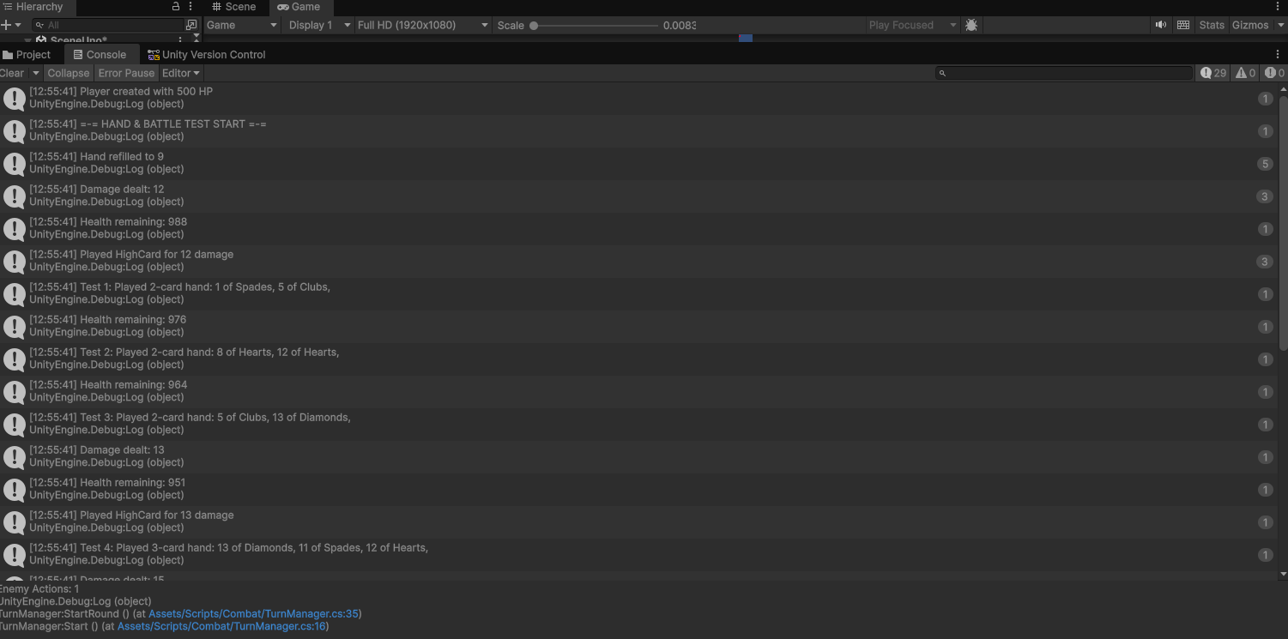
Creating a large scale test of played cards and player instances to ensure that the manager is properly calculating damage.
Result: Success, the hand manager object is correctly processing attacks and damage to a player instance.

Case 2:
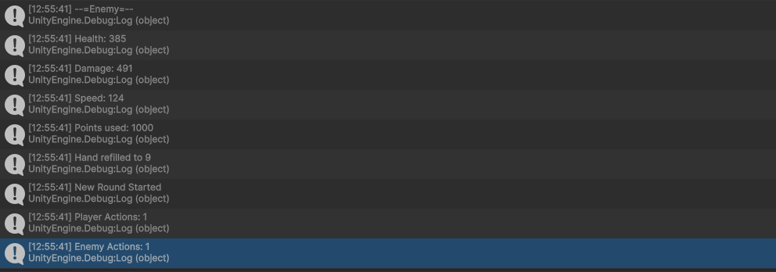
Creating multiple enemies to test if they are correctly allotting points to their stats.
Result: Success, the enemy spawner correctly creates enemies with an allotted number of points to their stats.

Case 3:
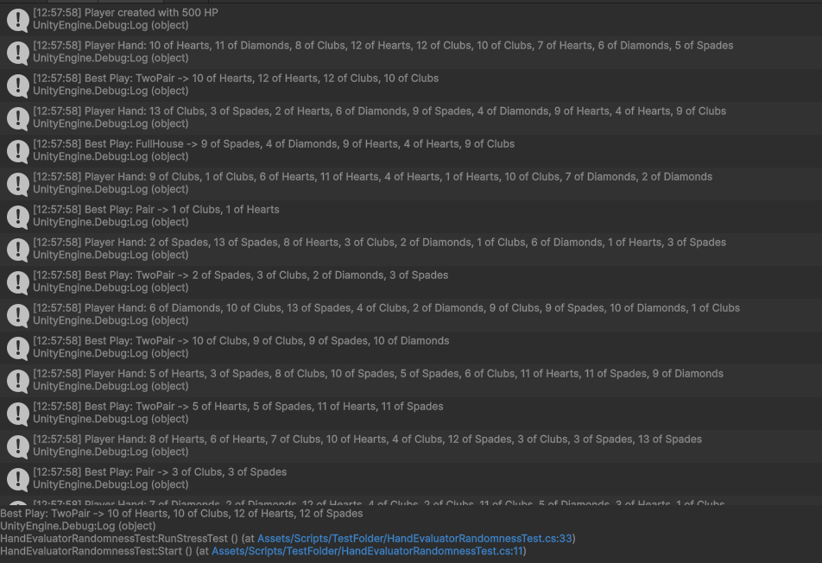
Creating multiple player hands full of cards to test whether the script to give the player cards is working correctly.
Result: Success, the deck manager object correctly gives the players the right amount of cards without any duplicates.

Case 4:
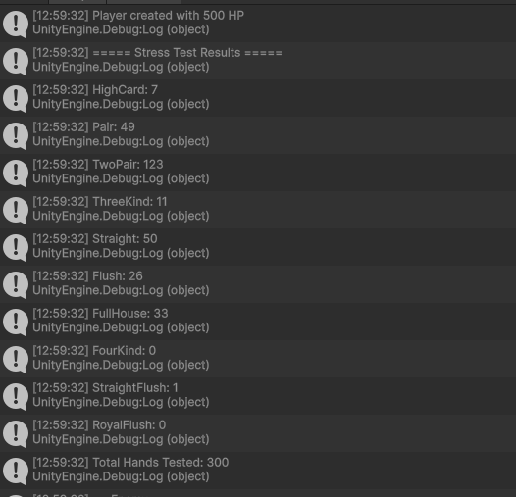
Using the previous test, log the best available hand and create many hands to test whether the probability of a hand is appearing as intended.
Result: Success, the probabilities are correct as each card has the same chance to be drawn, with the best hands being more rare than the more common ones.

Case 5:
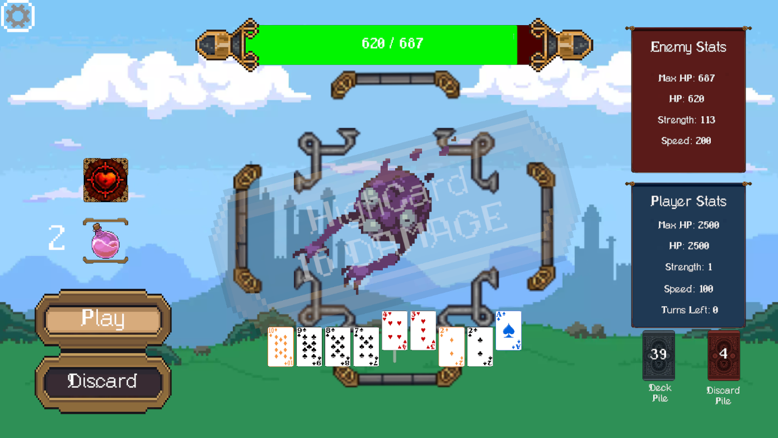
Attempting to do multiple actions while the previous action was still resolving. This tests if the game will have issues when a player attempts to make multiple actions in quick succession.
Result: Success, the game doesn’t have any errors when multiple actions are selected at once, simply ignoring all actions until the first action has properly resolved.

Case 6:
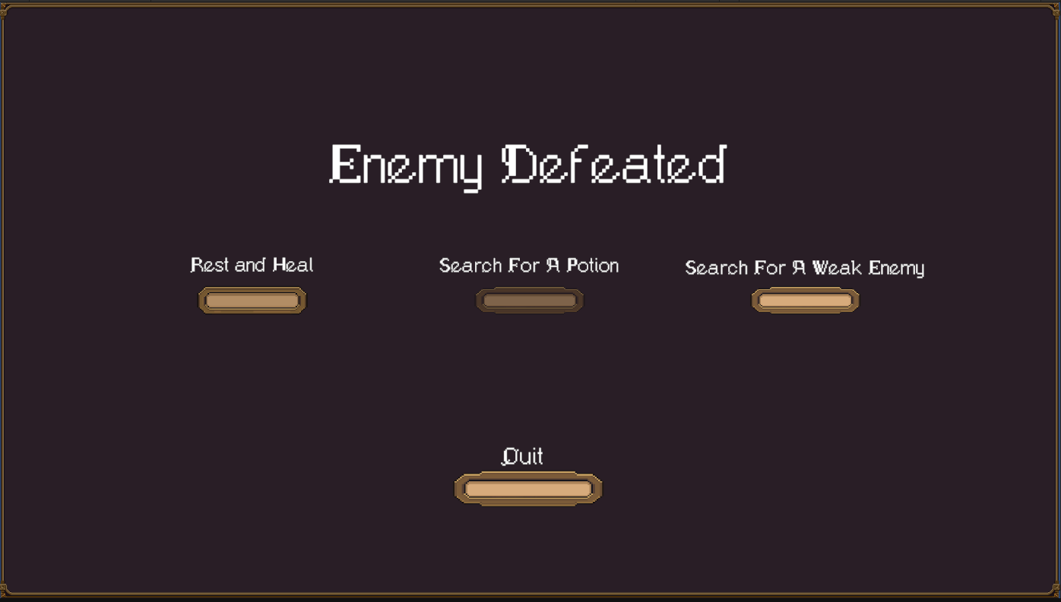
Spam clicking the decision buttons can allow the script to play multiple times, causing unintended errors or giving players too much power as they can potentially get the benefits of multiple options rather than just one.
Result: Success, the game does not allow interaction with the other buttons once a choice has been selected.

